Week 8 - Week commencing 21/3/2022

**Week Outline**

Online meeting. Meeting involved checking over calculations and code from last week as it was not quite right. Following this, this meeting was focused on wrapping up the project and discussing why the NEP was much lower than the photon noise limit. This was mainly attributed to the underestimate of the response. The other detector property was also determined, which was the detector yield. Otherwise, this was mostly a explanation session for why the detector behaves the way it does.

**Outline of Tasks**

* Calculate the detector yield for the SFAB arrays of total KIDS = 176
* Compare the NEP to the photon noise limit

**Detector Yield**

The detector yield is given as follows:

$$Yield= \frac{n_{responsive}}{n_{KID}}$$

Where $n_{responsive}$ is the number of responsive KIDs in the arrays that gave a hot bar response. $n_{KID}$ is the total number of KIDs in the array. For the SFAB system this was 176. From the NEP histogram from last week, it was found that there were $n_{responsive}=94$. So, this led to a detector yield of 53.4%. Out of the 176 KIDs, only 113 KIDs gave data outputs. The remainder of KIDs did not give I and Q values, which could be due to a wide range of problems, such as damage, defects, excess temperature fluctuations, etc. It can’t really be determined at this point in time, and it is also too advanced in terms of the report.

For the other detectors, they gave an unresolvable response, as shown by the red bars in the Histogram. These KIDs had dF0 data that could not have the hot bar peaks be identified. An example is shown: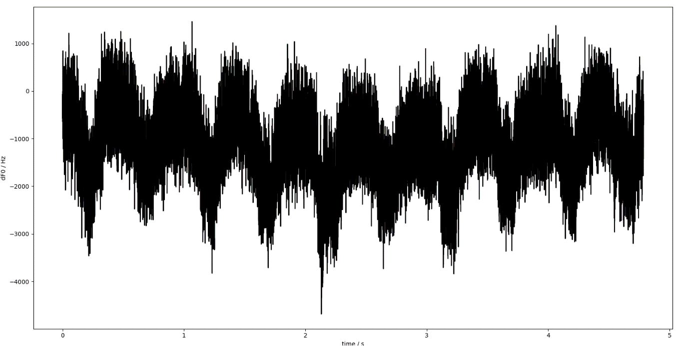

The dF0 timestream graph above shows that there are no hot bar peaks to be found, or easily identifiable. Most likely, the hot bar peaks are there, but the peaks are masked by excess noise from/on the detector. This could be due to a whole range of factors such as temperature fluctuations of the KID, interference, background noise, etc. As such, these KIDs were given a “Unresolvable Response” tag on the Histogram.

**NEP Comparison with the Photon Noise Limit**

The NEP can be calculated as a mean from the histogram. This is illustrated:

The green line was taken as the mean NEP and this was used to compare with the total photon noise limit calculated last week.

The ratio of mean NEP of the KID array to the total photon noise limit was found to be 5.88. This means that the KID array NEP was 5.88 times larger than the total photon noise limit. Ideal detectors should have NEPs that are photon noise limited. This means that perfect detectors have NEP equal to the photon noise limit. The reason for the KID to stray from the total photon noise limit is due to several factors, the first being an overestimate of the response. This is most likely due to underestimation of dF0. One major reason is due to the losses in the lenses. Since the lenses are made of propylene, which has refractive index of 1.5, the refractive index change causes significant losses through refraction and absorption as explained by my supervisor.

Another reason could be due to modelling the hot bar as a perfect blackbody. In reality, objects tend to radiate perfectly due to the surface materials that have emissivity lower than 1. This will decrease the dP calculated.

Final reason, could be due to excess noise causing NEP to increase. Since the NEP calculated is based on the noise spectral density, noise sources such as thermal noise, generation recombination of cooper pairs, interference and varying scenes will all contribute a noise level to the detector and increase the NEP.